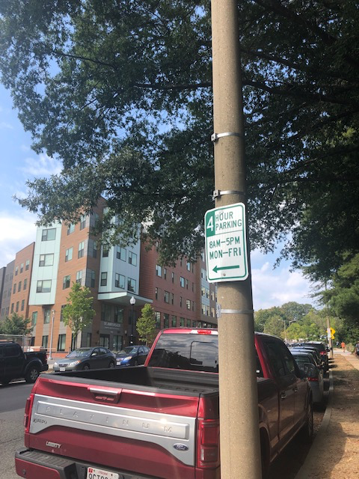

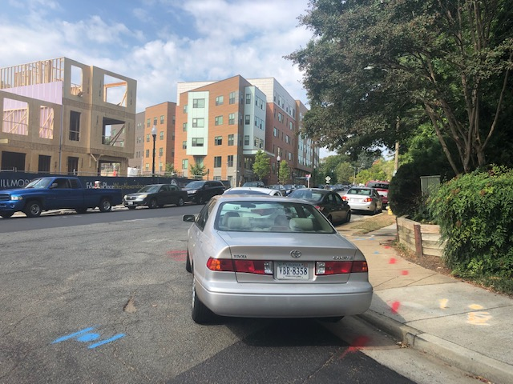

Cars parked at the intersection of Filmore Ave and Domain Pl. In the picture below, this pole used to have a red “no parking” sign pointing toward the right. Please replace it.

